Course Title: Social Immersive Learning
Course Code: 24UC0021
Name: L.Ishitha
Roll No: 2420030041
Section: 10

Title of the Topic:
Alumni Talk – How to Apply to Foreign Universities

Introduction:
Applying to foreign universities is a life-changing opportunity that allows students to experience global education and cultural diversity. It offers access to world-class learning environments, international research exposure, and broader career prospects. The journey requires careful planning—from choosing the right university and program to preparing academic records, test scores, and compelling personal statements.
Studying abroad not only enhances a student’s academic and professional profile but also nurtures independence, adaptability, and intercultural communication skills. This event focuses on simplifying the process and motivating students to pursue their academic aspirations confidently on an international platform.

About the Event:
The “How to Apply to Foreign Universities” Alumni Talk was organized to help students gain a comprehensive understanding of the overseas education application process. Experienced alumni shared their personal journeys, offering practical advice and first-hand insights into studying abroad.
The session covered key topics such as:
- Identifying the right university and program based on interests and career goals.
- Preparing essential application materials, including transcripts, SOPs (Statement of Purpose), and Letters of Recommendation (LORs).
- Guidance on standardized tests like IELTS, TOEFL, GRE, and GMAT.
- Exploring scholarship and financial aid opportunities.
- Step-by-step explanation of visa application procedures.
- Tips for adapting to new cultures and academic environments abroad.
The event also included an interactive Q&A session, where students clarified their doubts directly with alumni who had successfully secured admissions in reputed global universities. This created a practical and motivational atmosphere that encouraged students to take concrete steps toward their study-abroad goals.

Key Learnings:
- Understanding each phase of the foreign university application process.
- Importance of crafting a strong SOP and building an impressive academic profile.
- Awareness of scholarships, visa processes, and test requirements.
- Insights into cultural adaptability and life abroad.
- Motivation and real-world advice from alumni experiences.
- 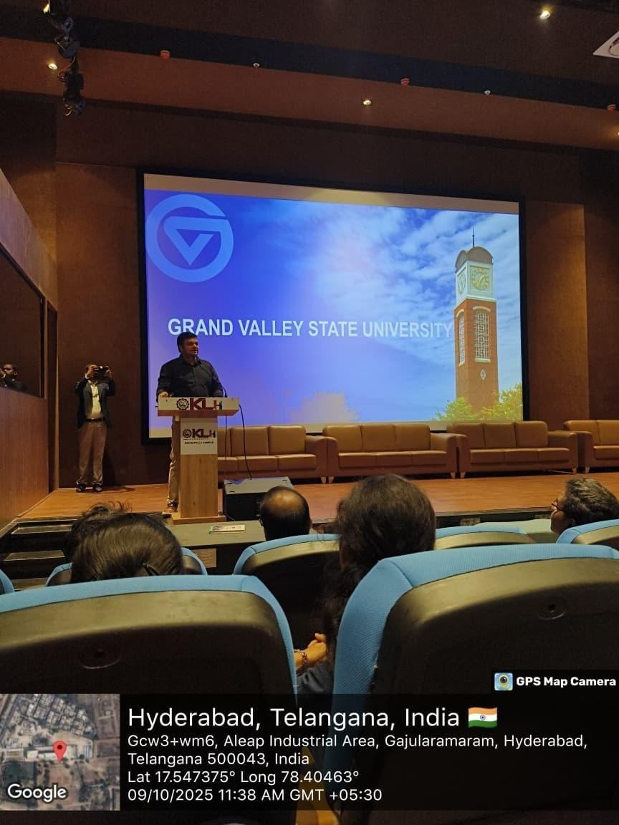

Conclusion:
The Alumni Talk on How to Apply to Foreign Universities was an extremely valuable session that equipped students with the necessary knowledge and confidence to pursue higher studies abroad. It bridged the gap between aspiration and action by providing clear, experience-based guidance. The event motivated participants to plan strategically, focus on personal development, and aim for global opportunities with greater clarity and determination.

